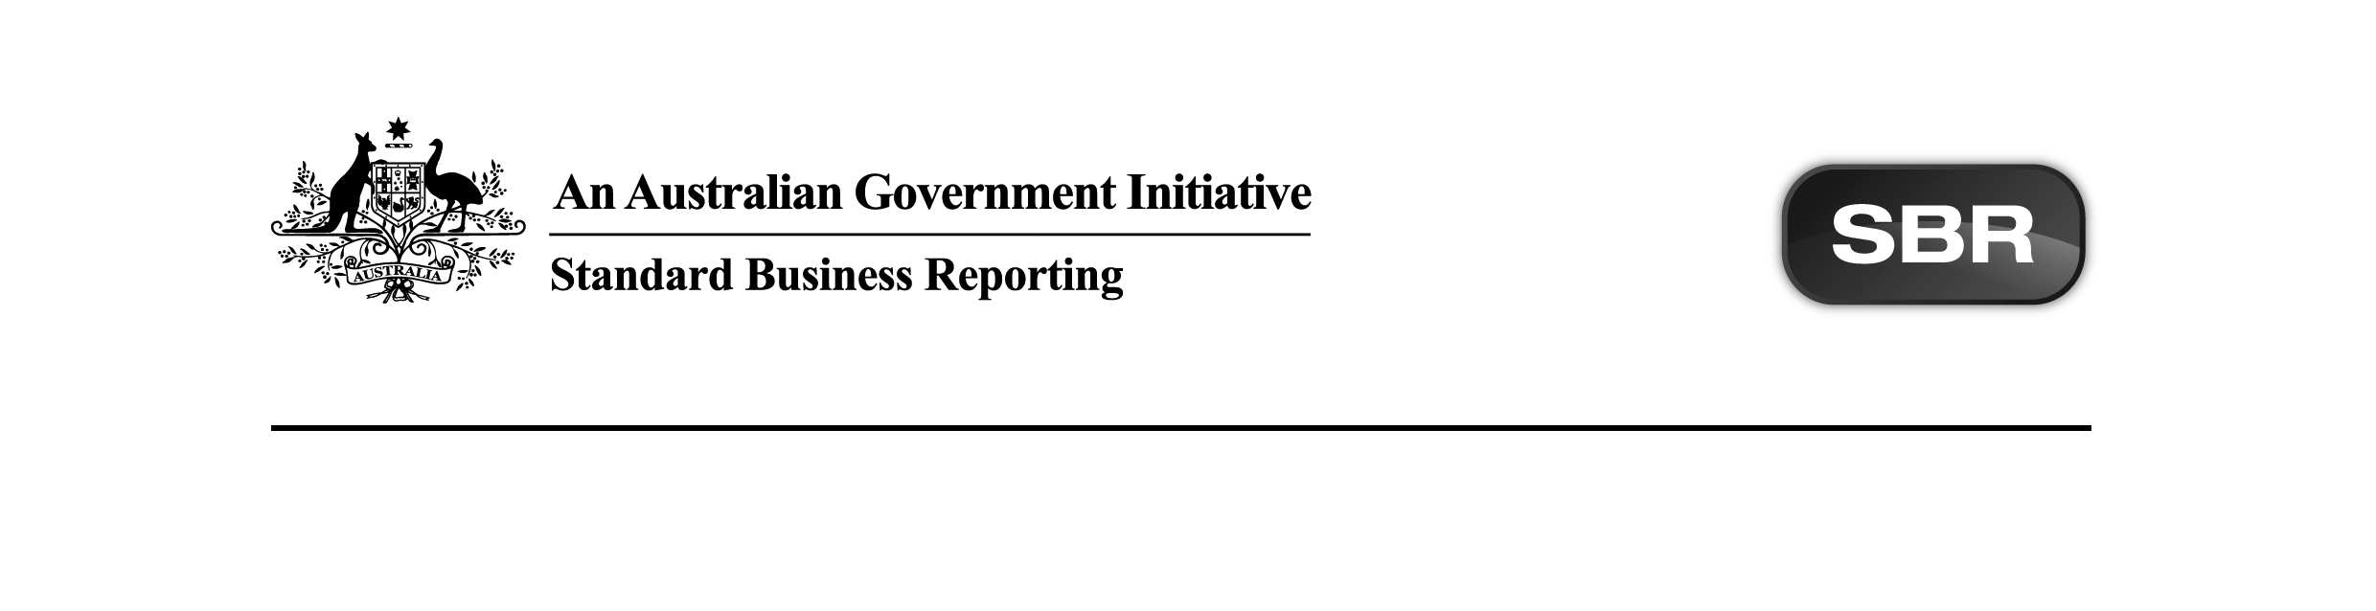
Standard Business Reporting
Australian Taxation Office

Client Update Return Not Necessary (CURNN.0002) 2016 Package v1.7 Contents

Date: 1st September 2022

This document and its attachments are Official | For further information or questions, contact the SBR Service Desk at SBRServiceDesk@sbr.gov.au

VERSION CONTROL
Version | Release date | Description of changes
1.7 | 01/09/2022 | Updated the CURNN.0002 2016 service with a functional change for September 2nd, 2022 EVTE deployment. The update will be deployed to PROD approximately 4 weeks after the EVTE deployment.  Section 2 Package Contents  Updated:  The following artefacts have been updated with a functional change to remove the format rule, which checks for invalid characters in non individual name field:  - ATO CURNN.0002 2016 Validation Rules.xlsx  - ATO CURNN.0002 2016 Schematron.zip

Copyright
© Commonwealth of Australia 2022 (see exceptions below).
This work is copyright. Use of this Information and Material is subject to the terms and conditions in the "SBR Disclaimer and Conditions of Use" which is available at http://www.sbr.gov.au. You must ensure that you comply with those terms and conditions. In particular, those terms and conditions include disclaimers and limitations on the liability of the Commonwealth and an indemnity from you to the Commonwealth and its personnel, the SBR Agencies and their personnel.
You must include this copyright notice in all copies of this Information and Material which you create. If you modify, adapt or prepare derivative works of the Information and Material, the notice must still be included but you must add your own copyright statement to your modification, adaptation or derivative work which makes clear the nature of your modification, adaptation or derivative work and you must include an acknowledgement that the adaptation, modification or derivative work is based on Commonwealth or SBR Agency owned Information and Material. Copyright in SBR Agency specific aspects of the SBR Reporting Taxonomy is owned by the relevant SBR Agency.

Table of contents
1 Introduction 5
1.1 Document purpose 5
1.2 Audience 5
1.3 Purpose of this package 5
1.4 Summary of artefacts the ATO packages 5
1.4.1 In general 5
1.4.2 Services 6
1.4.3 Interactions 6
1.4.4 Package artefact status description 6
2 Package contents 7
3 Known issues and future scope 8
3.1 Issues and incidents 8
3.2 Future scope 8
Appendix A – Prior Version History 9

Introduction

Document purpose
The purpose of this package content note (PCN) is to advise software developers of the package contents for Standard Business Reporting (SBR) Client Update Return Not Necessary (CURNN) 2016 product suite provided by the Australian Taxation Office (ATO).

Audience
The audience for this Package Content note is software developers who have or are interested in developing the CURNN service actions on the SBR ebMS3 platform in the XBRL format.

Purpose of this package
The purpose of this package is to streamline the way message artefacts are presented to software developers.

All relevant message artefacts that comprise the CURNN suite are contained within one zip file. The package will be versioned up each time artefacts are added or updated.

Summary of artefacts the ATO packages

In general
For each service, the following artefacts may be released under this package title:
- Message Repository
- Message Structure Tables (MSTs),
- Contract schemas and samples, and
- Validation Rules (VRs).

The first PCN released outlines the expected artefacts to be within the package at an end state – as known at that point in time.

As a general rule, each service will have at minimum an MST and VR.

Where a ‘suite’ of like services is packaged, there will be service specific MSTs and VRs packaged to form a bundle of related information.

The basic exception to the above is Income tax Returns. Due to complexity of relationships between parent returns and child schedules each has its own set of documents (MSTs and VRs) yet is packaged together as a ‘suite’.

Services
The following table shows the services that form the CURNN product suite and their relationship to previous service versions:
Description | Service | Change | Comments
Client Update Return Not Necessary 2016 | curnn.0002.2016 | Updated

Interactions
The following table lists the interactions for a given service.
Description | Interaction | Change | Comments
Client Update Return Not Necessary 2016 Submit | curnn.0002.2016.submit | Updated | The response message for CURNN is CU.

Detailed information on each service can be found in the Service Registry, along with associated messages.

Package artefact status description
The table in Section 2 Package Contents reflects the status of artefacts in the Package Status column and needs to be read in conjunction with the Comments column in order to understand the scale of change that may be applicable.

The table below describes the terminology used in the Package Status column and the business description of the package status:
Package Status | Business Description
Pending | The artefact is currently under development and is expected to be released in a future package.
New | The artefact is new for the package and has not been published previously. This would usually occur when an artefact has previously been marked as Pending (under development) or a new Government/ATO initiative sees the development of new services/messages to be deployed.
Updated | The artefact has changed since the last public release for this package. It could occur as a result of refining service/messages due to feedback or defects.
Present | The artefact is within the package and has had no change from the prior package for this year or a previous/forward year where artefacts cross multiple years.
Removed | The artefact was within the package in a prior release but has been removed as it is not relevant for the service/suite in question. This could occur due to Government legislation waiting on Royal Assent not being passed or other factors.

Package contents
The table below outlines the package contents.

Name | Document Date | Document Status | Version | Comments | Package Status
ATO CURNN.0002 2016 Message Structure Table.xlsx | 17/11/2016 | Final | 1.2 | No change from prior publication. | Present
ATO CU.0001 2014 Response Message Structure Table.xlsx | 21/04/2016 | Final | 1.2 | No change from prior publication. | Present
ATO CURNN.0002 2016 Validation Rules.xlsx | 01/09/2022 | Final | 1.7 | Removed validation rule: VR.ATO.GEN.500023, which checks for invalid characters in non individual name field. This check will be performed by the schema. | Updated
ATO CURNN.0002 2016 Schematron.zip | 01/09/2022 | Final | 1.7 | Removed validation rule: VR.ATO.GEN.500023, which checks for invalid characters in non individual name field. This check will be performed by the schema. | Updated

Total artefacts in this Package: | 04
Present artefacts | 02
New artefacts | 00
Updated artefacts | 02
Pending artefacts | 00
Removed artefacts | 00

- Known issues and future scope
The following is a list of issues and/or future work to be implemented. There may be impacts to successful development until the issues are resolved or the future scope has been implemented (as an example where a service is deployed over multiple iterations and won’t be complete for some time).

Issues and incidents
Issue  # | Issue Description | Impacted  Interactions | Reference Number | Resolution | Proposed  EVTE Date | Proposed  PROD Date | Issue Status (Open/  Closed)
N/A

Future scope
Change  # | Change Description | Impacted  Interactions | Proposed  EVTE Date | Proposed  PROD Date | Change Status (Open/  Closed)
N/A

Appendix A – Prior Version History
Version | Release date | Description of changes
1.6 | 20/08/2020 | Updated the CURNN.0002 2016 service with a functional change for August 2020 EVTE.  Section 2 Package Contents  Updated  The following artefacts have been updated with a functional change to allow non individual names with space hyphen space.  - ATO CURNN.0002 2016 Validation Rules.xlsx  - ATO CURNN.0002 2016 Schematron.zip  Removed  Reference to the following artefact has been removed from the package content note as it is not part of the ATO CURNN.0002 2016 Package.  - ATO CC.0001 2016 List Validation Rules.xlsx
1.5 | 17/05/2018 | Section 2 Package contents  Updated  Functional changes to implement removal of VR.ATO.GEN.410206  - ATO CURNN.0002 2016 Validation Rules.xlsx
1.0 | 07/12/2017 | Note: CURNN.0002 2016 artefacts were previously package within CU 2016. CURNN is the only Active service left as all other CU 206 services are Deprecated, hence it has been re-packaged on it’s own.  Section 2 Package contents  Updated  Functional changes – Interactive Errors and Document Control sheets added:  - ATO CURNN.0002 2016 Validation Rules.xlsx

