##### An Australian Government Initiative - SBR

Standard Business Reporting

Australian Taxation Office –

Self-managed Super Fund Member TFN Identity Check Service (SMSFMBRVRFY.0002)  
Business Implementation Guide

Date: 6 Febuary 2025

Status: Final

This document and its attachments are **Official**

For further information, raise an enquiry via [Online Services for DSPs](https://softwaredevelopers.ato.gov.au/OnlineservicesforDSPs). If you are unable to access this, contact [SBRServiceDesk@sbr.gov.au](mailto:SBRServiceDesk@sbr.gov.au) or call **1300 488 231**. International callers may use **+61-2-6216 5577**.

Version control

|  |  |  |
| --- | --- | --- |
| **Version** | **Release date** | **Description of changes** |
| 1.2 | 6/02/2025 | Updated hyperlink references and formatting. |
| 1.1 | 13/11/2024 | Update to reflect myGovID rename to myID |
| 1.0 | 29/04/2021 | Versioned to Final and added Usage Restrictions. |
| 0.1 | 15/12/2020 | Included access manager permission, updated AUSkey to myGovID, removal of URI field other minor wording updates. |

Endorsement

Belinda Black, Director, Superannuation and Employer Obligations – Endorsed for business context.

Ziva White, Director, Individuals and Intermediaries – Endorsed for publication.

Copyright

© Commonwealth of Australia 2025

This work is copyright. Use of this Information and Material is subject to the terms and conditions in the ‘SBR Disclaimer and Conditions of Use’ that is available at <http://www.sbr.gov.au>. You must ensure that you comply with those terms and conditions. In particular, those terms and conditions include disclaimers and limitations on the liability of the Commonwealth and an indemnity from you to the Commonwealth and its personnel, Standard Business Reporting Agencies and their personnel.

You must include this copyright notice in all copies of this Information and Material that you create. If you modify, adapt or prepare derivative works of the Information and Material, the notice must still be included but you must add your own copyright statement to your modification, adaptation or derivative work that makes clear the nature of your modification, adaptation or derivative work and you must include an acknowledgement that the adaptation, modification or derivative work is based on Commonwealth or SBR Agency owned Information and Material. Copyright in SBR Agency specific aspects of Standard Business Reporting Taxonomy is owned by the relevant SBR Agency.

Table of contents

1. Introduction 4

1.1 Purpose and document context 4

1.2 Glossary 4

2. What is the self-managed super fund member tfn identity check service? 7

2.1 Interactions 7

2.2 Channels 8

2.3 Mandatory use of the service 8

2.4 legislation provides the minimum message requirements 8

2.5 Message structure 9

2.6 Intermediary (sender) details 9

2.7 Reporting party (requesting provider) details 10

2.8 Individual’s (member’s) details 10

2.9 Individual’s (member’s) details 11

2.10 Invaild Responses 12

3. Authorisation 13

3.1 Intermediary relationship 13

3.2 Access Manager 13

4. Constraints and known issues 15

4.1 Contraints 15

4.2 Usage restrictions 15

Table 1 - Glossary of terms 4

Table 2: Interactions available in SMSFmemberTICK process 7

Table 3: Channel availability of SMSFmemberTICK interactions 8

Table 4: Intermediary details requirements 9

Table 5: Reporting part details requirements 10

Table 6: Member details requirements 10

Table 7: SMSFmemberTICK responses 11

Table 8: IITRPRFL interactions 14

Table 9: Access Manager permissions 14

# 1. Introduction

## 1.1 Purpose and document context

The purpose of this document is to provide information that will assist software developers in understanding the business context surrounding the Self-managed Superannuation Fund (SMSF) member tax file number (TFN) identity check service (SMSFmemberTICK) interactions. The interactions with this service are performed with the Australian Taxation Office (ATO) through the Standard Business Reporting (SBR) platform by, or on behalf of, any SMSF performing a rollover to another fund.

Specifically, SMSFmemberTICK refers to the interactions between an SMSF and the ATO, in order to validate a member’s TFN prior to performing a rollover on that member’s behalf to another super fund. The audience for this document is any SMSF (or their tax agent or software industry partner) that will be utilising the SMSFmemberTICK on the SBR ebMS3 platform.

The SMSFmemberTICK 2020 Business Implementation Guide forms part of the broader suite of documents used by the ATO to describe or interpret how the technical implementation relates back to the business context and process. This document is designed to be read in conjunction with the ATO SBR documentation suite including the:

[ATO Common Business Implementation and Taxpayer declaration Guide](https://www.sbr.gov.au/digital-service-providers/developer-tools/australian-taxation-office-ato/ato-common-artefacts-and-reference-documents#CBG)

web service/platform information

test information, for example conformance suites

Message Structure Tables

validation rules.

## 1.2 Glossary

Table 1 only contains terms that need specific explanation for this document. For a full glossary of terminology, see:

[SBR glossary](https://www.sbr.gov.au/digital-service-providers/developer-tools/glossary)

[ATO definitions](https://www.ato.gov.au/Definitions/?anchor=top).

**Table 1 - Glossary of terms**

|  |  |
| --- | --- |
| **Term** | **Definition** |
| APRA | Australian Prudential Regulation Authority. |
| BDE | Bulk Data Exchange. |
| Business Intermediary | A business intermediary is represented by the entity who is confirming the required SMSF details to process and complete a SuperStream transaction to a SMSF on behalf of the reporting party. |
| eBMS3 | Version 3 of the ATO’s default electronic commerce platform that utilises SBR to facilitate transaction message between the ATO’s online systems and end users. |
| EPF | Electronic portability form. |
| Employer | An employer who employs a person under a verbal or written employment contract on a full-time, part-time or casual basis (definition for superannuation guarantee purposes) |
| Intermediary's business name | The full name by which an intermediary is known. |
| Reporting Party | The reporting party can be represented as a major aggregator of super data who is confirming the required SMSF details to process and complete a SuperStream transaction to a SMSF |
| Self-managed superannuation fund bank account details | The name and account details of the SMSF bank account held by a financial institution. |
| SISA | *Superannuation Industry (Supervision) Act 1993*. |
| SMSF Electronic service address (ESA) | This is the electronic service address alias provided by the messaging service provider to the SMSF in order to receive SuperStream Standard messages. |
| SMSF Employee | An employee who has nominated an SMSF as their choice fund to receive their super contributions. |
| SRP | Single Request Processor – a service within ebMS3 that provides an interactive service for a single event or transaction. It is transaction by transaction service only and cannot receive transactions in bulk. |
| SuperTICK | A service that enables super funds (excluding self-managed super funds), their administrators and intermediaries to validate a member’s TFN. |
| Unique request identifier | This is an identifier generated by the business entity, used to uniquely identify the business document contained in the exchanged message. |

# 2. What is the self-managed super fund member tfn identity check service?

The Self-managed super fund member TFN identity check service (SMSFmemberTICK) is a web service that allows SMSFs to validate their member’s TFN prior to effecting an outward rollover.

More infromation about:

The SMSFmemberTICK service can be found on the [SBR website](https://www.sbr.gov.au/digital-service-providers/developer-tools/australian-taxation-office-ato/superannuation-data-and-reporting-standards/superannuation-spr#SMSFmember)

Data Standards is available on the [ATO website](https://www.ato.gov.au/businesses-and-organisations/super-for-employers/paying-electronically-through-superstream).

Notification of SMSFmemberTICK outages is available through the [Data Standards release notes](https://softwaredevelopers.ato.gov.au/supervalidationservices)

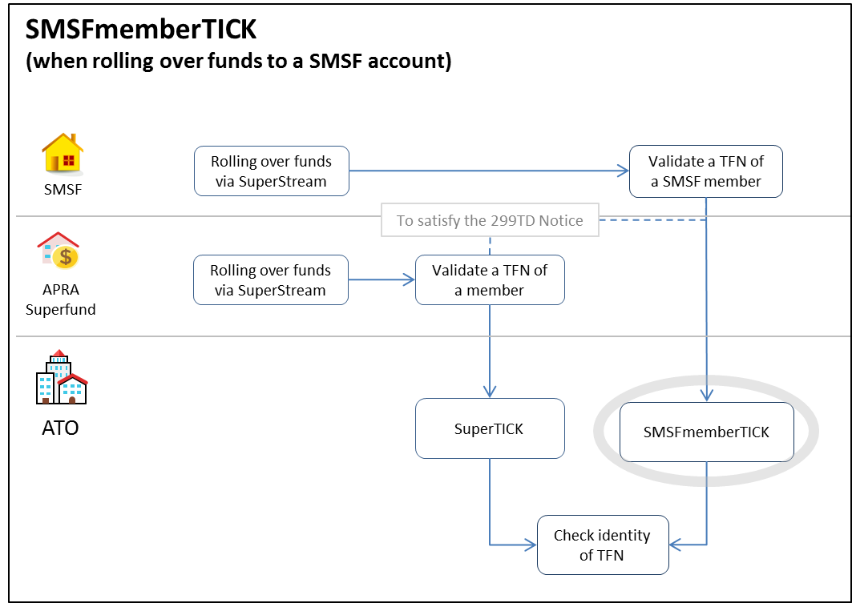Figure 1 - Transaction flow for the SMSFmemberTICK service

## 2.1 Interactions

Table 2: Interactions available in SMSFmemberTICK process

|  |  |  |  |
| --- | --- | --- | --- |
| **Interaction** | **Detail** | **Single** | **Batch** |
| SMSFMBRVRFY.0001.2020.Get | Enables SMSFs to validate member TFNs prior to a rollover | Y | N |

## 2.2 Channels

The SMSFmemberTICK interactions are available in the following channel:

Table 3: Channel availability of SMSFmemberTICK interactions

|  |  |  |  |
| --- | --- | --- | --- |
| **Channel** | **How request is lodged** | **When to use the channel** | **Timeframe for service response** |
| SRP | SBR ebMS3.0 enabled software | Single real time requests | refer to ATO Common Message Implementation Guide |

## 2.3 Mandatory use of the service

Under regulation 6.33D of the *Superannuation Industry (Supervision) Regulations 1994*, there is a requirement for any fund rolling over the whole or a part of a member’s withdrawal benefit, to request a notice from the Commissioner of the ATO (the Commissioner) validating that member’s information.

With the expansion of SuperStream rollovers to include any rollover to or from an SMSF, there is now a requirement for any SMSF undertaking an outward rollover to also obtain a statement from the Commissioner validating that member’s details.

## 2.4 legislation provides the minimum message requirements

Section 299TD of the *Superannuation Industry (Supervision) Act 1993* (SISA) requires the trustee of the superannuation fund to provide the Commissioner with information it believes to be:

The full name, TFN and date of birth of a person

The full name, TFN and date of birth and address of a person.

Although our systems may accept a message with a reduced data set, section 299TD of the SISA provides the legal requirements for a TFN validation message to receive a valid 299TD notice from the Commissioner.

Where mandatory member information is not provided or provided in an incorrect format, the request from the fund or sender will be rejected and an error response message returned.

In relation to the input address, ATO systems treat all addresses equally; we recommend a residential address or the latest address held for the member be provided in the request. Where an overseas address is input, the ‘Locality Name’ is to be populated with the overseas address (for example city, postcode) in addition to Address Line 1 and 2 (where applicable); no ‘Postcode’ or ‘State or Territory’ is to be populated as they are used exclusively for Australian addresses.

**Note: default or invalid TFNs**

In many circumstances a superannuation fund will be unaware that a member TFN may be a default or invalid TFN. There are circumstances where a fund could reasonably be expected to conclude that the TFN quoted is invalid for that member. Examples include where:

the code is a TFN exemption code provided by the employer (such as 111 111 111 or 444 444 444)

we have notified the fund that the TFN it holds is not the member’s TFN.

Default or invalid TFNs must not be used through the service.

## 2.5 Message structure

The SMSFmemberTICK message structure contains the following sections:

1. Intermediary (sender) details.
2. Reporting party (requesting provider) details.
3. Individual’s (member’s) details.

Where we refer to an item as ‘optional’, this is from an SBR messaging perspective in that a message can still be valid without the optional components. From a superannuation reporting point of view, these optional items must be reported where a fund holds that information (that is, they should be treated as ‘conditional’). For example a tax agent acting as an intermediary must include their tax agent number in the intermediary details section.

**Note:** The Message Structure Table and Validation Rules spreadsheets are to be read in conjunction with this business implementation guide.

## 2.6 Intermediary (sender) details

Used to report the details of the sender of the message. The sender must be the entity who has authorisation in Access Manager to report on behalf of the reporting party. The sender can be the reporting superannuation entity itself. This section is optional.

**Table 4: Intermediary details requirements**

|  |  |  |
| --- | --- | --- |
| **Intermediary** | **Requirement** | **Description** |
| Intermediary ABN | Mandatory | The intermediary ABN must be provided if the SMSFmemberTICK request is submitted by a Tax Agent or business intermediary |
| Intermediary's business name | Mandatory | The intermediary business name must be provided if the SMSFmemberTICK request is submitted by a Tax Agent or business intermediary |
| Tax agent number | Optional | The number of the tax agent acting as the intermediary |

## 2.7 Reporting party (requesting provider) details

Used to report the details of the reporting superannuation entity. This section is mandatory.

**Table 5: Reporting part details requirements**

|  |  |  |
| --- | --- | --- |
| **Reporting party details** | **Requirement** | **Description** |
| Reporting party ABN | Mandatory | The ABN of the transferring super fund. |
| Reporting party’s business name | Mandatory | The business name of the transferring super fund. |

## 2.8 Individual’s (member’s) details

Identifies to which member the request relates. This section is mandatory.

**Table 6: Member details requirements**

|  |  |
| --- | --- |
| **Individual's (member's) details** | **Requirement** |
| Individual's tax file number provided | Mandatory |
| Individual's day of birth | Optional |
| Individual's month of birth | Optional |
| Individual's year of birth | Mandatory |
| **Individual's name** |  |
| Individual's name - family name | Mandatory |
| Individual's name - given name | Optional |
| Individual's name - other given name | Optional |
| **Individual's address** |  |
| Individual's address - street name and number - line 1 | Optional |
| Individual's address - street name and number - line 2 | Optional |
| Individual's address - suburb/town | Optional |
| Individual's address - postcode | Optional |
| Individual's address - state or territory | Optional |
| Individual's address - country code | Optional |

When lodging a validation request, the individual’s year of birth and family name are mandatory. Where you do not hold the required mandatory data you should follow the conventions described in SuperStream guidance note 22 (see [Default values for mandatory fields when data is unavailable](https://softwaredevelopers.ato.gov.au/SSTC/Guidance)).

## 2.9 Individual’s (member’s) details

All successfully formatted requests will undergo identity matching, and will result in a matching response being returned and are to be treated as per the following table:

**Table 7: SMSFmemberTICK responses**

|  |  |  |
| --- | --- | --- |
| **Where the fund provides** | **and ATO can** | **ATO will provide a** |
| Correct TFN | Match to the member | Matched response  *GEN.OK + CMN.ATO.SMSFMBRVRFY.VALID* |
| Incorrect TFN | Match to the member | Unmatched response  *GEN.OK + CMN.ATO.SMSFMBRVRFY.NOTVALID* |
| Incorrect TFN | Not match to the member | Unmatched response  *GEN.OK + CMN.ATO.SMSFMBRVRFY.NOTVALID* |

**Note:** The ATO will not issue corrected TFNs through this service.

## 2.10 Invaild Responses

A response of ‘not valid’ means we were unable to match the member details provided to our records with an appropriate level of confidence.

We may have been unable to match the member details for the following reasons:

your member has provided you with incorrect details

the records we hold are incorrect

the TFN has a compromised or duplicate status on our systems

our data matching system cannot establish a single match.

We are unable to identify those element/s that have prevented us from finding a match to an individual.

You should confirm the details you hold for the member are correct.

If you contact your member and they confirm the details you hold are correct the member should update their details with us directly by:

telephoning 13 28 61 between 8.00am and 6.00pm weekdays, or

updating their details [here](https://www.ato.gov.au/individuals-and-families/tax-file-number/update-your-tfn-registration-details/update-your-personal-contact-details).

**Note:** The member should have a copy of a personalised ATO document (such as a personal income tax assessment from the last three years) for identity purposes.

# 3. Authorisation

## 3.1 Intermediary relationship

The type of SBR service an intermediary can use on behalf of their clients depends on the activity being undertaken and whether the intermediary has a recognised relationship with the client. That is, an intermediary has the appropriate authorisation for the interaction being performed on behalf of the taxpayer recorded in ATO systems.

A tax agent to SMSF relationship must be appointed by the tax agent to use the available services on the fund’s behalf. The tax practitioner to taxpayer relationship is a fundamental precondition to interacting with SBR for all activity statement interactions.

A business intermediary must be appointed by a Reporting party (SMSF) in Access Manager to use the available services on their behalf.

**Note:** If the relationship does not exist, the SBR Add Client Relationship interaction of the Client Update services can be used to establish a relationship between the intermediary and the taxpayer.

See the:

[ATO Client Update Relationship 2018 Business Implementation Guide](https://www.sbr.gov.au/sites/default/files/ATO-CUREL-0004.2018-Business-Implementation-Guide.docx) for further information

SBR website for more information on [client management](https://www.sbr.gov.au/digital-service-providers/developer-tools/australian-taxation-office-ato/obligation-management-oblmgt/client-management-clntmgt).

## 3.2 Access Manager

Access Manager is used to manage access and permissions for SBR online services. ATO systems will check that the initiating party is allowed to use the interaction that is received through the SBR channel. The initiating party is subject to restrictions on the clients account based on their Access Manager permissions.

For more information on Access Manager, see the [ATO website](https://www.ato.gov.au/General/online-services/access-manager/). The table below displays the interactions available to each initiating party via SBR for the SMSFmemberTICK services.

Table 8: IITRPRFL interactions

|  |  |  |  |  |  |
| --- | --- | --- | --- | --- | --- |
| **Interaction** | **Activity** | **Tax agent** | **BAS agent** | **Business** | **Business Intermediary** |
| SMSFMBRVRFY.0001.2020.Get | Request validation of an SMSF member’s TFN. | Y | N | Y | N |

A user must be assigned the appropriate authorisation permissions to use the AS service. The below table references the SBR service to the relevant permission in Access Manager.

Table 9: Access Manager permissions

|  |  |
| --- | --- |
| **Service** | **Access Manager Permission** |
| SMSFMBRVRFY.0001.2020.Get | SMSF - Search and verify members |

# 4. Constraints and known issues

## 4.1 Contraints

There are no known SMSFMBRVRFY service constraints known at the time of publishing.

## 4.2 Usage restrictions

Digital Service Providers (DSPs) must be aware of the usage restrictions, which are described within the [Reasonable Use policy](https://softwaredevelopers.ato.gov.au/sites/default/files/2020-06/Reasonable_use_of_ATO_digital_wholesale_services.pdf). The ATO actively monitors the use of services and will notify DSPs that contravene this policy. Continued breaches may result in de-whitelisting.