##### An Australian Government Initiative - SBR

Standard Business Reporting

Australian Taxation Office –

Self-managed Super Fund Verification Service (SMSFVRFY.0002)  
Business Implementation Guide

Date: 6 February 2025

Status: Final

This document and its attachments are **Official**

For further information, raise an enquiry via [Online Services for DSPs](https://softwaredevelopers.ato.gov.au/OnlineservicesforDSPs). If you are unable to access this, contact [SBRServiceDesk@sbr.gov.au](mailto:SBRServiceDesk@sbr.gov.au) or call **1300 488 231**. International callers may use **+61-2-6216 5577**.

Version control

|  |  |  |
| --- | --- | --- |
| **Version** | **Release date** | **Description of changes** |
| 1.2 | 06/02/2025 | Updated hyperlink references and formatting. |
| 1.1 | 13/11/2024 | Updated to reflect myGovID rename to myID |
| 1.0 | 29/04/2021 | Versioned to Final and added Usage Restrictions. |
| 0.1 | 15/12/2020 | Included access manager permission, updated AUSkey to myGovID, removal of URI field, other minor wording updates. |

Endorsement

Belinda Black, Director, Superannuation and Employer Obligations – Endorsed for business context.

Ziva White, Director, Individuals and Intermediaries – Endorsed for publication.

Copyright

© Commonwealth of Australia 2025

This work is copyright. Use of this Information and Material is subject to the terms and conditions in the ‘SBR Disclaimer and Conditions of Use’ that is available at <http://www.sbr.gov.au>. You must ensure that you comply with those terms and conditions. In particular, those terms and conditions include disclaimers and limitations on the liability of the Commonwealth and an indemnity from you to the Commonwealth and its personnel, Standard Business Reporting Agencies and their personnel.

You must include this copyright notice in all copies of this Information and Material that you create. If you modify, adapt or prepare derivative works of the Information and Material, the notice must still be included but you must add your own copyright statement to your modification, adaptation or derivative work that makes clear the nature of your modification, adaptation or derivative work and you must include an acknowledgement that the adaptation, modification or derivative work is based on Commonwealth or SBR Agency owned Information and Material. Copyright in SBR Agency specific aspects of Standard Business Reporting Taxonomy is owned by the relevant SBR Agency.

Table of contents

1. Introduction 4

1.1 Purpose and document context 4

1.2 Glossary 4

2. What is the self-managed super fund verification service? 7

2.1 Service overview 7

2.2 Verification of smsf details 8

2.3 Interactions 9

2.4 Channels 9

2.5 Mandatory use of the service 9

2.6 Message structure 9

2.7 Intermediary (sender) details 10

2.8 Reporting party (requesting provider) details 10

2.9 Individual’s (member’s) details 11

2.10 SMSF details 11

3. Authorisation 12

3.1 Intermediary relationship 12

3.2 Access Manager 12

4. Using the smsf verification service 14

4.1 Contraints 14

4.2 Usage restrictions 14

4.3 Conditions of use 14

4.4 How to manage responses 14

4.4 Not verified - SMSF 15

4.5 Not verified - member 16

Table 1 - Glossary of terms 5

Table 2: Interactions available in SMSFmemberTICK process 9

Table 3: Channel availability of SVS interactions 9

Table 4: Intermediary details requirements 10

Table 5: Reporting part details requirements 10

Table 6: Member details requirements 11

Table 7: SMSF details requirements 11

Table 8: SMSF interactions 12

Table 9: Access Manager permissions 13

# 1. Introduction

## 1.1 Purpose and document context

The purpose of this document is to provide information that will assist digital service providers in understanding the business context surrounding the Self-managed Superannuation Fund (SMSF) Verification Service (SVS) interactions. These interactions are performed with the Australian Taxation Office (ATO) through the Standard Business Reporting (SBR) platform by, or on behalf of, any SMSF or Australian Prudential Regulation Authority (APRA) regulated fund (APRA fund) completing an SuperStream rollover to an SMSF.

The SVS is part of a suite of services supporting the implementation of the SuperStream Standard (‘the Standard’), part of the Government’s Super Reform package. SuperStream improves the client experience by reducing cost and effort while making it easier to track people’s money. The Standard provides a consistent, reliable electronic method of transacting linked superannuation data and payments.

The audience for this document is any SMSF, and any APRA fund (or their administrator or software industry partner) that will be utilising the SVS on the SBR ebMS3 platform.

This SVS Business Implementation Guide (BIG) forms part of the broader suite of documents used by the ATO to describe or interpret how the technical implementation relates back to the business context and process. This document forms part of the broader suite of documents used by the ATO to describe or interpret how the technical implementation relates back to the business context and process. This document is designed to be read in conjunction with the ATO SBR documentation suite including the:

[ATO Common Business Implementation and Taxpayer declaration Guide](https://www.sbr.gov.au/digital-service-providers/developer-tools/australian-taxation-office-ato/ato-common-artefacts-and-reference-documents#CBG)

web service/platform information

test information, for example conformance suites

Message Structure Tables

validation rules.

## 1.2 Glossary

Table 1 only contains terms that need specific explanation for this document. For a full glossary of terminology, see:

* [SBR glossary](https://www.sbr.gov.au/digital-service-providers/developer-tools/glossary)
* [ATO definitions](https://www.ato.gov.au/Definitions/?anchor=top).

**Table 1 - Glossary of terms**

|  |  |
| --- | --- |
| **Term** | **Definition** |
| APRA | Australian Prudential Regulation Authority. |
| BDE | Bulk Data Exchange. |
| Business Intermediary | A business intermediary is represented by the entity who is confirming the required SMSF details to process and complete a SuperStream transaction to a SMSF on behalf of the reporting party. |
| eBMS3 | Version 3 of the ATO’s default electronic commerce platform that utilises SBR to facilitate transaction message between the ATO’s online systems and end users. |
| EPF | Electronic portability form. |
| Employer | An employer who employs a person under a verbal or written employment contract on a full-time, part-time, or casual basis (definition for superannuation guarantee purposes). |
| ESA | Electronic service address for a relevant entity. |
| Intermediary's business name | The full name by which an intermediary is known. |
| Major aggregators | Entities that have the capability and resources to build, implement and access the SVS. These entities include any of the following: APRA funds and their administrators, payroll providers, clearing houses and digital service providers. |
| Reporting Party | The reporting party can be represented as a major aggregator of super data who is confirming the required SMSF details to process and complete a SuperStream transaction to a SMSF. |
| Self-managed superannuation fund bank account details | The name and account details of the SMSF bank account held by a financial institution. |
| SISA | *Superannuation Industry (Supervision) Act 1993*. |
| SMSF Electronic service address (ESA) | This is the electronic service address alias provided by the messaging service provider to the SMSF in order to receive SuperStream Standard messages. |
| SMSF Employee | An employee who has nominated an SMSF as their choice fund to receive their super contributions. |
| SMSFmemberTICK | The service by which an SMSF can validate a member’s Tax File Number (TFN) prior to completing a rollover. |
| SRP | Single Request Processor – this is a service within ebMS3 that provides an interactive service for a single event or transaction. It is a transaction by transaction service only and cannot receive transactions in bulk. |
| Unique request identifier | This is an identifier generated by the business entity, used to uniquely identify the business document contained in the exchanged message. |

# 2. What is the self-managed super fund verification service?

## 2.1 Service overview

The SMSF Verification Service (SVS) is a web service that will provide authorised entities (such as APRA Funds their administrators and SMSFs) with the ability to verify SMSF details prior to making SuperStream transactions to SMSFs.

The SVS will verify the following:

SMSF status (Complying or Regulated)

that the TFN of the individual is associated with the SMSF

no verified date of death exists for the individual/SMSF member associated with the SMSF

SMSF bank details held by the ATO (see note below)

Electronic Service Address (ESA) held by the ATO.

In addition, the SVS will return the certification status of the DSP of the SMSF, this will enable the transferring fund to determine how they can interact with the receiving SMSF.

The use of the SVS will be mandatory from 31 March 2021* for transferring funds and their administrators due to the legislative requirement for them to use an electronic service upheld by the ATO to confirm SMSF details prior to completing a rollover to an SMSF.

*(*While the legislated compliance date is 31 March 2021, an administrative deferral has been implemented to extend this to 30 September 2021.)*

The service made available through the SVS:

*SMSFVRFY.0001.2020.Get* – allows authorised entities to verify information held by the ATO regarding SMSF details to interact and complete a SuperStream transaction with a SMSF.

**Note:** The SVS will not validate a member’s TFN. To meet this requirement:

APRA funds must use either the Member Account Attribution Service ([MAAS](https://www.sbr.gov.au/digital-service-providers/developer-tools/australian-taxation-office-ato/superannuation-data-and-reporting-standards/superannuation-spr#sprmbr)) or [SuperTICK](https://www.ato.gov.au/super/superstream/in-detail/validation-services/supertick-user-guide/) service

SMSFs use the SMSFmemberTICK.

The SVS will only verify that the SMSF bank account details in the request match those held by the ATO. Bank details will not be verified with the financial institution.

## 2.2 Verification of SMSF details

The SMSFVRFY.0001.2020.Get is an interaction that allows funds to verify SMSF details held by the ATO prior to processing SuperStream rollover payments and data messages. This service will provide a single channel for upfront verification.

For example, an APRA fund or their administrator may use this service prior to processing a rollover request from an SMSF member/Trustee as result of receiving either:

Schedule 2B ‘Rollover initiation request to transfer of whole balance of superannuation benefits to self-managed superannuation fund’, or

Electronic Portability Form (EPF) from the ATO.

Using this service will confirm SMSF details and provide a greater level of confidence that both monies and messages are going to the appropriate SMSF. It will also assist APRA funds with meeting their obligations under ‘know your client’ in respect of rollovers to SMSFs.

**Note**: that where an APRA fund receives an EPF from the ATO, the SMSF/member details will have already been verified prior to issuing this form. Therefore, in this instance there would be no requirement for the fund to separately use the SVS (for the fund to meet their obligations under 6.33E of the *Superannuation Industry (Supervision) Regulations 1994* (SISR). They may however choose to do so, if this fits with their system design.

APRA funds and their administrators must not solely rely on the SVS to meet their ‘know your client’ obligations. They are still required to use their current processes and procedures prior to processing rollovers to SMSFs to satisfy their own Trustee processes and obligations.

Figure 1 - Transaction flow for the SMSF verification service

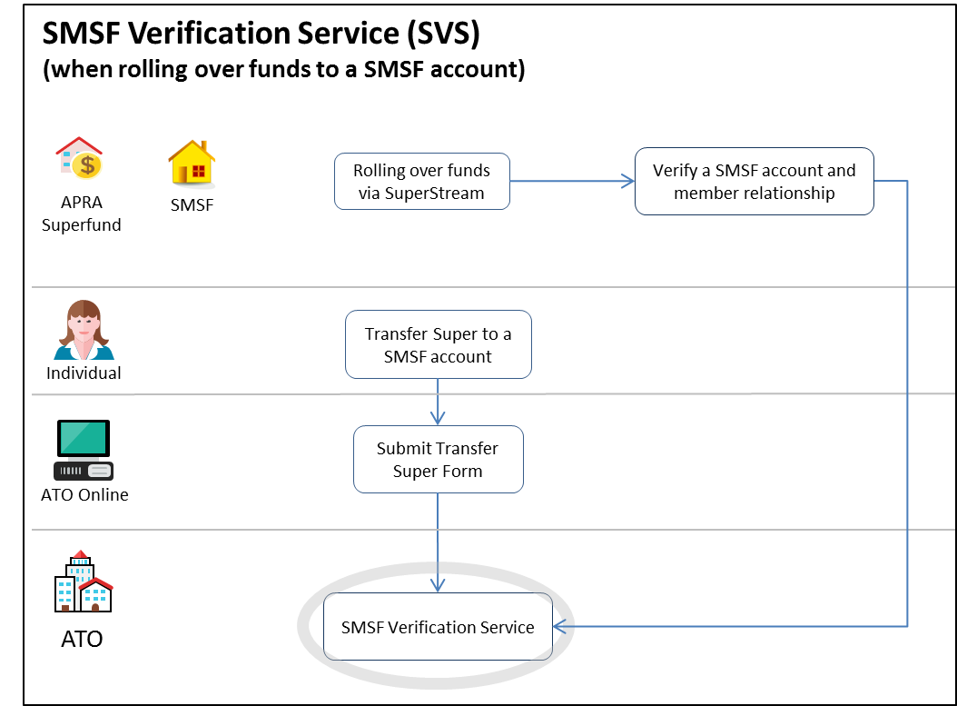

## 2.3 Interactions

Table 2: Interactions available in SMSFmemberTICK process

|  |  |  |  |
| --- | --- | --- | --- |
| **Interaction** | **Detail** | **Single** | **Batch** |
| SMSFMBRVRFY.0001.2020.Get | This service enables the verification of an SMSF's details prior to sending SuperStream rollover payments and messages to the SMSF | Y | N |

## 2.4 Channels

Table 3: Channel availability of SVS interactions

|  |  |  |  |
| --- | --- | --- | --- |
| **Channel** | **How request is lodged** | **When to use the channel** | **Timeframe for service response** |
| SRP | SBR ebMS3.0 enabled software | Single real time requests | refer to ATO Common Message Implementation Guide |

## 2.5 Mandatory use of the service

Regulation 6.33E of the SISR requires funds to use an electronic service upheld by the ATO to verify certain information that relates to an SMSF when making a rollover to an SMSF including:

Australian Business Number (ABN) and the name of the SMSF

complying status of the SMSF

that the individual/member initiating the rollover is a member of the SMSF

the bank details of the SMSF

the ESA of the SMSF.

The SVS is the electronic service by which transferring funds can verify these details.

## 2.6 Message structure

The SVS message structure contains the following sections:

1. Intermediary (sender) details
2. Reporting party (requesting provider) details
3. SMSF details
4. Individual’s (member’s) details.

Where we refer to an item as ‘optional’, this is from an SBR messaging perspective in that a message can still be valid without the optional components. From a superannuation reporting point of view, these optional items must be reported where a fund holds that information (that is, they should be treated as ‘conditional’). For example, a tax agent acting as an intermediary must include their tax agent number in the intermediary details section.

**Note:** The Message Structure Table and Validation Rules spreadsheets are to be read in conjunction with this business implementation guide.

## 2.7 Intermediary (sender) details

Used to report the details of the sender of the message. The sender must be the entity who has authorisation in Access Manager to report on behalf of the reporting party. The sender can be the reporting superannuation entity itself. This section is optional.

**Table 4: Intermediary details requirements**

|  |  |  |
| --- | --- | --- |
| **Intermediary** | **Requirement** | **Description** |
| Intermediary ABN | Mandatory | The intermediary ABN must be provided if the SVS is submitted by a Tax Agent or business intermediary. |
| Intermediary's business name | Mandatory | The intermediary business name must be provided if the SVS is submitted by a Tax Agent or business intermediary. |
| Tax agent number | Optional | The number of the tax agent acting as the intermediary. |

## 2.8 Reporting party (requesting provider) details

Used to report the details of the reporting superannuation entity. This section is mandatory.

**Table 5: Reporting part details requirements**

|  |  |  |
| --- | --- | --- |
| **Reporting party details** | **Requirement** | **Description** |
| Reporting party ABN | Mandatory | The ABN of the transferring super fund. |
| Reporting party’s business name | Mandatory | The business name of the transferring super fund. |

## 2.9 Individual’s (member’s) details

Identifies to which member the request relates. This section is mandatory.

**Table 6: Member details requirements**

|  |  |
| --- | --- |
| **Individual's (member's) details** | **Requirement** |
| Individual's tax file number provided | Mandatory |

## 2.10 SMSF details

This is used to report the details of the SMSF, for which the reporting party is attempting verification. This section is mandatory.

**Table 7: SMSF details requirements**

|  |  |
| --- | --- |
| **SMSF details** | **Requirement** |
| SMSF ABN | Mandatory |
| SMSF ESA alias | Mandatory |
| **SMSF bank details** |  |
| SMSF bank account name | Mandatory |
| SMSF bank state branch (BSB) | Mandatory |
| SMSF bank account number | Mandatory |

**Note:** The SVS does not verify the SMSF bank account name but is required in the request for internal record keeping purposes.

# 3. Authorisation

## 3.1 Intermediary relationship

The type of SBR service an intermediary can use on behalf of their clients depends on the activity being undertaken and whether the intermediary has a recognised relationship with the client. That is, an intermediary has the appropriate authorisation for the interaction being performed on behalf of the taxpayer recorded in ATO systems.

A tax agent to SMSF relationship must be appointed by the tax agent to use the available services on the fund’s behalf. The tax practitioner to taxpayer relationship is a fundamental precondition to interacting with SBR for all activity statement interactions.

A business intermediary must be appointed by a Reporting party (APRA fund or SMSF) in Access Manager to use the available services on their behalf.

**Note:** If the relationship does not exist, the SBR Add Client Relationship interaction of the Client Update services can be used to establish a relationship between the intermediary and the taxpayer.

See the:

[ATO Client Update Relationship 2018 Business Implementation Guide](https://www.sbr.gov.au/sites/default/files/ATO-CUREL-0004.2018-Business-Implementation-Guide.docx) for further information

SBR website for more information on [client management](https://www.sbr.gov.au/digital-service-providers/developer-tools/australian-taxation-office-ato/obligation-management-oblmgt/client-management-clntmgt).

## 3.2 Access Manager

Access Manager is used to manage access and permissions for SBR online services. ATO systems will check that the initiating party is allowed to use the interaction that is received through the SBR channel. The initiating party is subject to restrictions on the clients account based on their Access Manager permissions.

For more information on Access Manager, see the [ATO website](https://www.ato.gov.au/General/online-services/access-manager/). The table below displays the interactions available to each initiating party via SBR for the SMSF services.

Table 8: SMSF interactions

|  |  |  |  |  |  |
| --- | --- | --- | --- | --- | --- |
| **Interaction** | **Activity** | **Tax agent** | **BAS agent** | **Business** | **Business Intermediary** |
| SMSFMBRVRFY.0001.2020.Get | Request verification of SMSF details held by the ATO and receive outcome responses/messages from the ATO in relation to the submitted requests | Y | N | Y | N |

A user must be assigned the appropriate authorisation permissions to use the AS service. The below table references the SBR service to the relevant permission in Access Manager.

Table 9: Access Manager permissions

|  |  |
| --- | --- |
| **Service** | **Access Manager Permission** |
| SMSFMBRVRFY.0001.2020.Get | SMSF - Verification service for rollovers/contributions |

# 4. Using the SMSF verification service

## 4.1 Constraints

There are no known SMSFMBRVRFY service constraints known at the time of publishing.

## 4.2 Usage restrictions

Digital Service Providers (DSPs) must be aware of the usage restrictions, which are described within the [Reasonable Use policy](https://softwaredevelopers.ato.gov.au/sites/default/files/2020-06/Reasonable_use_of_ATO_digital_wholesale_services.pdf). The ATO actively monitors the use of services and will notify DSPs that contravene this policy. Continued breaches may result in de-whitelisting.

## 4.3 Conditions of use

The SVS can only be used in accordance with the terms and conditions of use that apply at the time of the transaction. Your access and use signifies your acceptance of the [DSP conditions of use](https://softwaredevelopers.ato.gov.au/usingourservices/dsp-conditions-use).

We will monitor use of the service, and may contact the reporting party, or their authorised representative for clarification of transactions processed through the service.

The SVS must only be used by or on behalf of trustees of super entities, regulated exempt public sector super schemes and/or RSA providers and only for the purposes for which it is designed. Where a person holding a myID accesses or uses the SVS other than in accordance with the terms and conditions, the ATO (in addition to any other rights it may have):

may terminate the ability of that myID to access the SVS services

may report the matter to the entity or entities for whom that myID is held or purportedly used, and to the authority who issued that myID.

## 4.4 How to manage responses

The service compares the SMSF’s ABN and the SMSF member’s TFN received in the request message from a transferring entity (reporting party) against the SMSF’s information held in the ATO client register.

Data matching processes are used to determine whether the SMSF’s ABN is linked to the SMSF member’s details, provided those data elements can be matched against ATO records to the satisfactory level of confidence.

For successfully processed messages, the service will provide a validation response (GEN.OK) and either a ‘verified’ (CMN.ATO.SMSFVRFY.VALID) or ‘not verified’ response.

There are two different not verified responses:

1. CMN.ATO.SMSFVRFY.SMSFNOTVALID.
2. CMN.ATO.SMSFVRFY.MEMNOTVALID.

These identify (respectively) whether we were unable to verify the SMSF’s, or the SMSF member’s details. These errors will have a short description detailing ‘SMSF/Member [as appropriate] details were unable to be verified’.

Where a ‘not verified’ response is returned, you may choose (at your discretion) to not proceed with the rollover.

The SMSF DSP gateway certification will be returned, in addition to the verification outcome, as a value in the SVS response message. This will depend on the ATO being able to derive the SMSF DSP gateway from the SMSF ESA provided by the calling fund, as well as the certification value provided to the ATO by the SMSF DSP gateway.

## 4.4 Not verified - SMSF

A ‘SMSFNOTVALID’ response can be caused by one of the following three reasons:

1. provided ABN is not registered as an SMSF.
2. SMSF ABN is not compliant or not regulated.
3. SMSF FIA and/or ESA is either incomplete or does not match ATO records.

Where you elect to not proceed with the rollover, if the rollover was commenced:

by the receipt of an initiate rollover request (IRR) from an SMSF you should respond with the error code ‘**SUPER.GEN.GEN.25 Unable to verify SMSF information**’. This error code will be a trigger for the SMSF to contact the ATO and take the required corrective action

directly by your member, advise them to contact the ATO to update their SMSF’s details.

Once the SMSF/individual has resolved the issue, the rollover will need to be re-initiated.

Instructions for how an SMSF can update their details can be found on [Changes to your SMSF](https://www.ato.gov.au/super/self-managed-super-funds/administering-and-reporting/notify-us-of-changes/).

An individual can update their details with us directly by:

telephoning 13 28 61 between 8.00am and 6.00pm weekdays, or

updating their details [here](https://www.ato.gov.au/Individuals/Tax-file-number/Update-your-details/)

**Note:** the member should have a copy of a personalised ATO document (such as a personal income tax assessment from the last three years) for identity purposes.

## 4.5 Not verified - member

A ‘MEMNOTVALID’ response can be caused by one of the following three reasons:

1. the individual’s TFN is not linked to SMSF.
2. the individual’s TFN is compromised.
3. ATO holds a date of death for the individual.

Where you elect to not proceed with the rollover, if the rollover was commenced:

by the receipt of an IRR from an SMSF you should respond with the error code ‘**SUPER.GEN.GEN.26 Unable to verify SMSF member**’. This error code will be a trigger for the SMSF (or their member) to contact the ATO and take the required corrective action

directly by your member, advise them to contact the ATO to take the required action.

Once the issue has been resolved, the rollover will need to be re-initiated.

Instructions for how an SMSF can update their details can be found on [ato.gov.au](https://www.ato.gov.au/super/self-managed-super-funds/administering-and-reporting/notify-us-of-changes/).

An individual can update their details with us directly by:

telephoning 13 28 61 between 8.00am and 6.00pm weekdays, or

updating their details [here](https://www.ato.gov.au/individuals-and-families/tax-file-number/update-your-tfn-registration-details/update-your-personal-contact-details).

**Note:** the member should have a copy of a personalised ATO document (such as a personal income tax assessment from the last three years) for identity purposes.