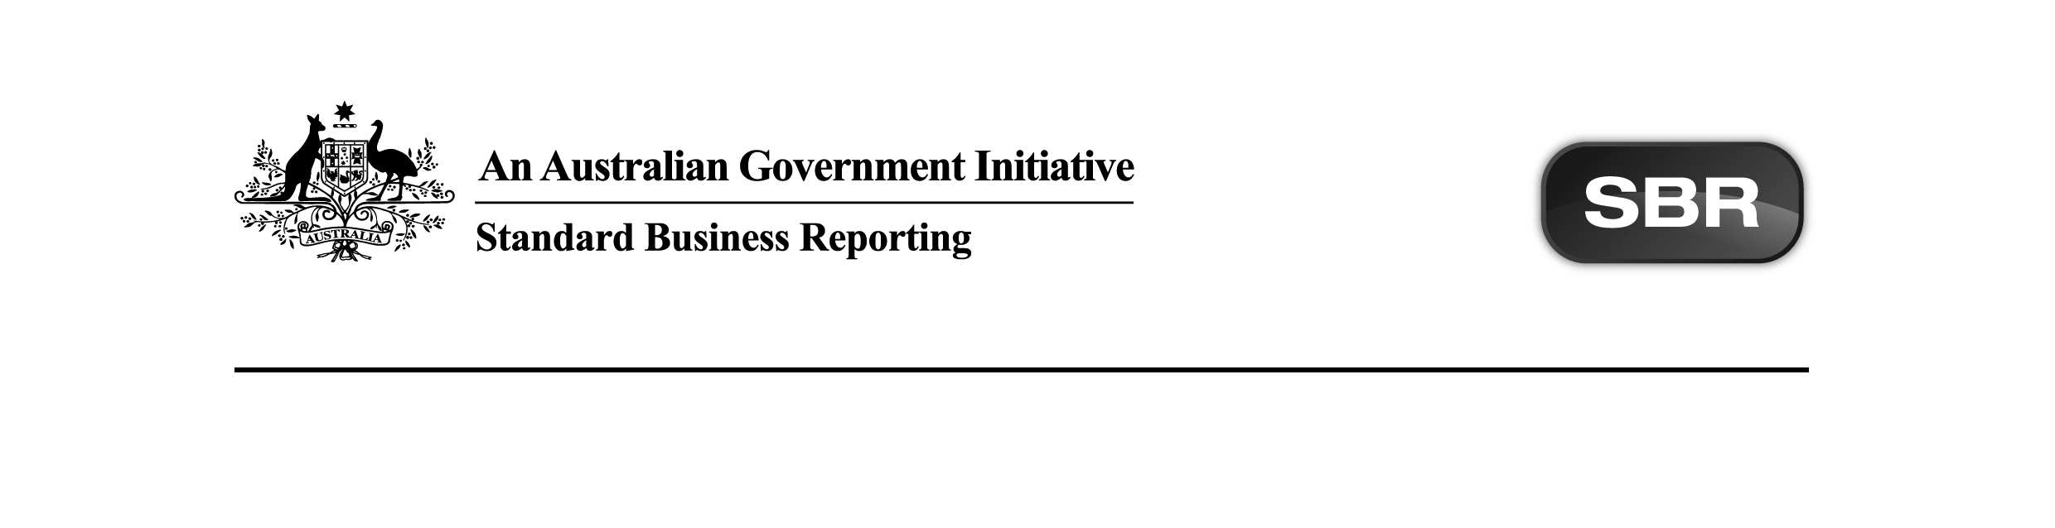
Standard Business Reporting
Australian Taxation Office

ABNREGSTS 2017 Package v1.0 Contents

Date: 20th April 2017

This document and its attachments are Unclassified | For further information or questions, contact the SBR Service Desk at SBRServiceDesk@sbr.gov.au or call 1300 488 231. International callers may use +61-2-6216 5577

VERSION CONTROL

Version | Release date | Description of changes
1.0 | 20.04.2017 | Final version with no functional changes

Copyright
© Commonwealth of Australia 2017 (see exceptions below).
This work is copyright. Use of this Information and Material is subject to the terms and conditions in the "SBR Disclaimer and Conditions of Use" which is available at http://www.sbr.gov.au. You must ensure that you comply with those terms and conditions. In particular, those terms and conditions include disclaimers and limitations on the liability of the Commonwealth and an indemnity from you to the Commonwealth and its personnel, the SBR Agencies and their personnel.
You must include this copyright notice in all copies of this Information and Material which you create. If you modify, adapt or prepare derivative works of the Information and Material, the notice must still be included but you must add your own copyright statement to your modification, adaptation or derivative work which makes clear the nature of your modification, adaptation or derivative work and you must include an acknowledgement that the adaptation, modification or derivative work is based on Commonwealth or SBR Agency owned Information and Material. Copyright in SBR Agency specific aspects of the SBR Reporting Taxonomy is owned by the relevant SBR Agency.

Table of contents
1 Introduction 4
1.1 Purpose 4
1.2 Audience 4
1.3 Purpose of this package 4
1.4 Summary of artefacts in the ATO packages 4
1.4.1 In general 4
1.4.2 Circumstances where artefacts are not present in a package 5
1.4.3 New services 5
1.4.4 New message associated with services (child relationship) 5
2 Package contents 6
3 Known issues and future scope 7
Appendix A – Prior Version History 8

- Introduction
  - Purpose
The purpose of this document is to advise software developers of the package contents for Standard Business Reporting (SBR) ABN Registration Status (ABNREGSTS) 2017 provided by the Australian Taxation Office (ATO).
  - Audience
The audience for this release note is software developers who have or are interested in developing ABNREGSTS services in the SBR Core Services platform.
  - Purpose of this package
The purpose of this package is to streamline the way message artefacts are presented to software developers.

All relevant message artefacts that comprise the ABNREGSTS suite are contained within one zip file. The package will be versioned up each time artefacts are added or updated.
  - Summary of artefacts in the ATO packages
    - In general
For each service, the following artefacts have been/will be released:
- XSD Message Instances
- Message Structure Tables (MSTs)

Note: From September 2016 the Message Implementation Guide/s (MIGs) will not be produced and will be replaced by the ATO Service Registry which is published under the ATO Common information artefacts section on all ATO pages on sbr.gov.au.
    - Circumstances where artefacts are not present in a package
The table in Section 2 Package Contents reflects the status of artefacts in the Package Status column and needs to be read in conjunction with the Comments column in order to understand the scale of change that may be applicable.

The table below describes the terminology used in the Package Status column and the business description of the package status:

Package Status | Business Description
Pending | The artefact is currently under development and is expected to be released in a future package.
New | The artefact is new for the package and has not been published previously. This would usually occur when an artefact has previously been marked as Pending (under development) or a new Government/ATO initiative sees the development of new services/messages to be deployed.
Present | The artefact is within the package and has had no change from the prior package for this year or a previous/forward year where artefacts cross multiple years.
Removed | The artefact was within the package in a prior release but has been removed as it is not relevant for the suite in question. This could occur due to Government legislation waiting on Royal Assent not being passed or other factors.
Updated | The artefact has changed since the last public release for this package. It could occur as a result of refining service/messages due to feedback or defects.

    - New services
There are no new services for this release.

    - New message associated with services (child relationship)
There are no new messages for this release.

- Package contents
The table below outlines the package contents.

Name | Document Date | Document Status | Version | Comments | Package Status
ATO ABNREGSTS.0002 2017 Csharp Rule Implementation.zip | 20.04.2017 | Final | 1.0 | Non-functional changes in this version:  Folder versioned up to Final (1.0) | Updated
ATO ABNREGSTS.0002 2017 Response Message Structure Table.xlsx | 20.04.2017 | Final | 1.0 | Non-functional changes in this version:  Folder versioned up to Final (1.0) | Updated
ATO ABNREGSTS.0002 2017 Request Message Structure Table.xlsx | 20.04.2017 | Final | 1.0 | Non-functional changes in this version:  Folder versioned up to Final (1.0) | Updated
ato.abnregsts.0002.2017.prefill.01.00.xsd | 20.04.2017 | Final | 1.0 | Final version with no functional changes | Present
ato.abnregsts.0002.2017.prefill.response.01.00.xsd | 20.04.2017 | Final | 1.0 | Final version with no functional changes | Present

Total artefacts in this Package: | 05
Present artefacts | 02
New artefacts | 00
Updated artefacts | 03
Pending artefacts | 00
Removed artefacts | 00

- Known issues and future scope
The following is a list of issues or future work to be implemented for this tax time. There may be impacts to successful development until the issues are resolved or the further work implemented.

Issue | Impacted Service | Incident Number | Internal Reference | Resolution | EVTE Deployment
None

Appendix A – Prior Version History
Version | Release date | Description of changes
0.1 | 16.03.2017 | Draft publication release for 2017 ABNREGSTS service to support the EVTE code deployment on the 16th March 2017. This package contains ‘New’ artefacts.  Note: ‘New’ artefacts are draft for consultation and describe (at a high level) new artefacts.  New:  - ATO ABNREGSTS.0002 2017 Csharp Rule Implementation.zip  - ATO ABNREGSTS.0002 2017 Request Message Structure Table.xlsx  - ATO ABNREGSTS.0002 2017 Response Message Structure Table.xlsx  - ato.abnregsts.0002.2017.prefill. 01.00.xsd  - ato.abnregsts.0002.2017.prefill.response.01.00.xsd

