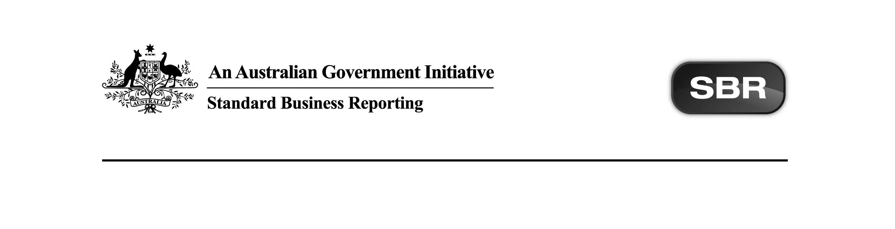
Standard Business Reporting
Australian Taxation Office

Lodgment List 2016
Package v1.0 Contents

Date: 16 June 2016

This document and its attachments are Unclassified | For further information or questions, contact the SBR Service Desk at SBRServiceDesk@sbr.gov.au or call 1300 488 231. International callers may use +61-2-6216 5577

VERSION CONTROL

Version | Release date | Description of changes
0.1 | 24/03/2016 | Initial release.
1.0 | 16/06/2016 | Final.

ENDORSEMENT
APPROVAL
Chief Solutions Architect
Standard Business Reporting

Michael Ferris | Program Manager  eCommerce Service Delivery  Australian Taxation Office

Copyright
© Commonwealth of Australia 2016 (see exceptions below).
This work is copyright. Use of this Information and Material is subject to the terms and conditions in the "SBR Disclaimer and Conditions of Use" which is available at http://www.sbr.gov.au. You must ensure that you comply with those terms and conditions. In particular, those terms and conditions include disclaimers and limitations on the liability of the Commonwealth and an indemnity from you to the Commonwealth and its personnel, the SBR Agencies and their personnel.
You must include this copyright notice in all copies of this Information and Material which you create. If you modify, adapt or prepare derivative works of the Information and Material, the notice must still be included but you must add your own copyright statement to your modification, adaptation or derivative work which makes clear the nature of your modification, adaptation or derivative work and you must include an acknowledgement that the adaptation, modification or derivative work is based on Commonwealth or SBR Agency owned Information and Material. Copyright in SBR Agency specific aspects of the SBR Reporting Taxonomy is owned by the relevant SBR Agency.

Table of contents
1 Introduction 5
1.1 Document purpose 5
1.2 Audience 5
1.3 Purpose of this package 5
1.4 Summary of impacts on software developers 5
1.4.1 In general 5
2 Package contents 7

Introduction

Document purpose
The purpose of this document is to advise software developers of the package contents for Standard Business Reporting (SBR) Lodgment List (LDGLST) 2016 service provided by the Australian Taxation Office (ATO).

Audience
The audience for this Package Content Note is software developers who are interested in developing LDGLST service into their products using the ATO ebMS3 protocol with the message payload constructed using the JavaScript Object Notation (JSON) format.

Purpose of this package
The purpose of this package is to streamline the way message artefacts are presented to software developers.

All relevant message artefacts that comprise the LDGLST service are contained within one zip file. The package will be versioned up each time artefacts are added or updated.

Summary of impacts on software developers

In general
For each service, the following artefacts have been/will be released under this package title:
- Message Implementation Guide (MIG),
- Message Structure Tables (MSTs),
- JSON Contracts,
- Validation Rules (VRs) and
- Message Repository.

The table in Section 2 Package Contents reflects the status of artefacts in the Package Status column and needs to be read in conjunction with the Comments column in order to understand the scale of change that may be applicable.

The table below describes the terminology used in the Package Status column and the business description of the package status:

Package Status | Business Description
Pending | The artefact is currently under development and is expected to be released in a future package.
New | The artefact is new for the package and has not been published previously. This would usually occur when an artefact has previously been marked as Pending (under development) or a new Government/ATO initiaitive sees the development of new services/messages to be deployed.
Updated | The artefact has changed since the last public release for this package. It could occur as a result of refining service/messages due to feedback or defects.
Present | The artefact is within the package and has had no change from the prior package for this year or a previous/forward year where artefacts cross multiple years.
Removed | The artefact was within the package in a prior release but has been removed as it is not relevant for the service/suite in question. This could occur due to Government legislation waiting on Royal Assent not being passed or other factors.

Package contents
The table below outlines the package contents.

Name | Document Date | Document Status | Version | Comments | Package Status
ATO LDGLST 2016 Message Implementation Guide.docx | 16/06/2016 | Final | 1.0 | Final. No change from version 0.1. | Updated
ATO LDGLST 2016 Message Repository.zip | 16/06/2016 | Final | 1.0 | Final. No change from version 0.1. | Updated
ATO LDGLST.0002 2016 List JSON Contracts.zip | 16/06/2016 | Final | 1.0 | Final. No change from version 0.1. | Updated
ATO LDGLST.0002 2016 List Request Message Structure.xlsx | 16/06/2016 | Final | 1.0 | Final. No change from version 0.1. | Updated
ATO LDGLST.0002 2016 List Response Message Structure.xlsx | 16/06/2016 | Final | 1.0 | Final. No change from version 0.1. | Updated
ATO LDGLST.0002 2016 List Validation Rules.xlsx | 16/06/2016 | Final | 1.0 | Final. No change from version 0.1. | Updated

Total artefacts in Package: 6

