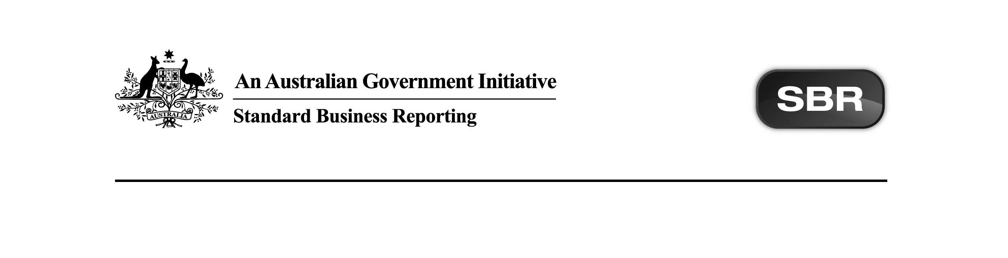
Standard Business Reporting
Australian Taxation Office

MAT.0001 2015 Package v1.0 Contents

Date: 19th April 2018

This document and its attachments are Unclassified | For further information or questions, contact the SBR Service Desk at SBRServiceDesk@sbr.gov.au or call 1300 488 231. International callers may use +61-2-6216 5577

VERSION CONTROL

Version | Release date | Description of changes
1.0 | 19/04/2018 | All artefacts versioned to Final. No functional changes.
0.4 | 16/07/2015 | This document has been updated for the July 2015 EVTE Release.  Updates:  The following artefacts have been updated with functional changes:  - ATO MAT.0001 2015 Message Repository.xml- Updated response messages to include Interactive Error Handler messages.  - ATO MAT.0001 2015 Schematron.zip- refer below.  Refer to section 2 of this document for a description of the change relevant to an artefact.
0.3 | 21/05/2015 | This document has been updated for the May 2015 EVTE Release.  Updates:  The following artefact has been updated to include the Interactive Error Handler messages:  - ATO MAT.0001 2015 Message Repository.xml  The following artefacts have been updated with non-functional changes:  - ATO MAT.0001 2015 Message Implementation Guide.docx  Refer to section 2 of this document for a description of the change relevant to an artefact.
0.2 | 16/04/2015 | This document has been updated for the April 2015 EVTE Release.  Updates:  The following artefacts have been published as ‘Final’ on the SBR Website:  - All Reporting and Definitional Taxonomies for MAT.0001 2015:  - mat.0001 (request and response)  The following artefact has been updated to correct the id’s in the Alias column with no functional change and versioned to FINAL:  - ATO MAT.0001 2015 Request Message Structure Table.xlsx  The following artefact has been updated with functional change and versioned to FINAL:  - ATO MAT.0001 2015 Response Message Structure Table.xlsx -  Updates to the following  MAT.00011 = Min occurs from 0 to 1  MAT.00012 = Min occurs from 0 to 1 and pyin.02.21 to pyin.02.22  Removed ".0001" from Alias column.  The following artefact has been updated with no functional changes and versioned to FINAL:  - ATO MAT.0001 2015 Message Implementation Guide.docx  Refer to section 2 of this document for a description of the change relevant to an artefact.
0.1 | 22/01/2015 | Initial release.

ENDORSEMENT
APPROVAL
Chief Solutions Architect
Standard Business Reporting

Michael Ferris | Program Manager  eCommerce Service Delivery  Australian Taxation Office

Copyright
© Commonwealth of Australia 2018 (see exceptions below).
This work is copyright. Use of this Information and Material is subject to the terms and conditions in the "SBR Disclaimer and Conditions of Use" which is available at http://www.sbr.gov.au. You must ensure that you comply with those terms and conditions. In particular, those terms and conditions include disclaimers and limitations on the liability of the Commonwealth and an indemnity from you to the Commonwealth and its personnel, the SBR Agencies and their personnel.
You must include this copyright notice in all copies of this Information and Material which you create. If you modify, adapt or prepare derivative works of the Information and Material, the notice must still be included but you must add your own copyright statement to your modification, adaptation or derivative work which makes clear the nature of your modification, adaptation or derivative work and you must include an acknowledgement that the adaptation, modification or derivative work is based on Commonwealth or SBR Agency owned Information and Material. Copyright in SBR Agency specific aspects of the SBR Reporting Taxonomy is owned by the relevant SBR Agency.

Table of contents
1 Introduction 6
1.1 Purpose 6
1.2 Audience 6
1.3 Purpose of this package 6
1.4 Summary of impacts on software developers 6
1.4.1 In general 6
2 Package contents 7

- Introduction
  - Purpose
The purpose of this document is to advise software developers of the package contents for Standard Business Reporting (SBR) Tax Practitioner Manage Tax Agent Trust (MAT) 2015 service provided by the Australian Taxation Office (ATO).
  - Audience
The audience for this release note is software developers who are interested in developing MAT services on the SBR ebMS3 platform.
  - Purpose of this package
The purpose of this package is to streamline the way message artefacts are presented to software developers.

All relevant message artefacts that comprise the MAT suite are contained within one zip file. The package will be versioned up each time artefacts are added or updated.
  - Summary of impacts on software developers
    - In general
For each service/message, the following artefacts have been released:
- Message Implementation Guide (MIG),
- Message Structure Table (MST),
- Message Repository (MR),
- Reporting Taxonomy where still in draft (RT),
- Schematron zip file,
- Validation Rules (VR) and
- Release Note (RN) when a change has occurred.

The table in Section 2 Package Contents reflects the status of artefacts in the Package Status column and needs to be read in conjunction with the Comments column in order to understand the scale of change that may be applicable.

The table below describes the terminology used in the Package Status column and the business description of the package status:

Package Status | Business Description
Pending | The artefact is currently under development and is expected to be released in a future package.
New | The artefact is new for the package and has not been published previously. This would usually occur when an artefact has previously been marked as Pending (under development) or a new Government/ATO initiative sees the development of new services/messages to be deployed.
Present | The artefact is within the package and has had no change from the prior package for this year or a previous/forward year where artefacts cross multiple years.
Removed | The artefact was within the package in a prior release but has been removed as it is not relevant for the suite in question. This could occur due to Government legislation waiting on Royal Assent not being passed or other factors.
Updated | The artefact has changed since the last public release for this package. It could occur as a result of refining service/messages due to feedback or defects.

- Package contents
The table below outlines the package contents.

Name | Document Date | Document Status | Version | Comments | Package Status
ATO MAT.0001 2015 Message Repository.xml | 19.04.2018 | Final | 1.0 | Versioned to Final – no functional change. | Updated
ATO MAT.0001 2015 Request Message Structure Table.xlsx | 07.04.2015 | Final | 1.0 | No change from prior publication. | Present
ATO MAT.0001 2015 Response Message Structure Table.xlsx | 10.03.2015 | Final | 1.0 | No change from prior publication. | Present
ATO MAT.0001 2015 Schematron.zip | 19.04.2018 | Final | 1.0 | Versioned to Final – no functional change. | Updated
ATO MAT.0001 2015 Validation Rules.xlsx | 19.04.2018 | Final | 1.0 | Versioned to Final – no functional change. | Updated
Total artefacts in package: 5

