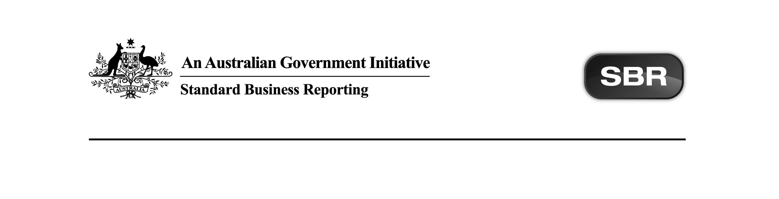
Standard Business Reporting
Australian Taxation Office

ATO NITR 2014 Business Implementation Guides Package v1.1 Contents

Date: 06th July 2017

This document and its attachments are Unclassified | For further information or questions, contact the SBR Service Desk at SBRServiceDesk@sbr.gov.au or call 1300 488 231. International callers may use +61-2-6216 5577

VERSION CONTROL

Version | Release date | Description of changes
1.1 | 06.07.2017 | Updated :  - ATO IEE.0002 2011 Business Implementation Guide.docx  Non-functional -  - 2.1 Where SBR fits into IEE Lodgment Obligations  Figure 1: SBR interactions and Interposed entity election  process  - Termination points deleted.  - 2.2 Parent Forms  - Collaborations updated to reflect 2017 service registry entries.  New :  - ATO FTER.0001 2011 Business Implementation Guide.docx – synchronisation with 2015 through to 2017 BIG packages.  Present :  - ATO CHTWTHHLD.0001 2014 Business Implementation Guide.docx  - ATO CGNFT.0001 2014 Business Implementation Guide.docx  Pending :  Not applicable.  Removed:  Not applicable.
Copyright
© Commonwealth of Australia 2017 (see exceptions below).
This work is copyright. Use of this Information and Material is subject to the terms and conditions in the "SBR Disclaimer and Conditions of Use" which is available at http://www.sbr.gov.au. You must ensure that you comply with those terms and conditions. In particular, those terms and conditions include disclaimers and limitations on the liability of the Commonwealth and an indemnity from you to the Commonwealth and its personnel, the SBR Agencies and their personnel.
You must include this copyright notice in all copies of this Information and Material which you create. If you modify, adapt or prepare derivative works of the Information and Material, the notice must still be included but you must add your own copyright statement to your modification, adaptation or derivative work which makes clear the nature of your modification, adaptation or derivative work and you must include an acknowledgement that the adaptation, modification or derivative work is based on Commonwealth or SBR Agency owned Information and Material. Copyright in SBR Agency specific aspects of the SBR Reporting Taxonomy is owned by the relevant SBR Agency.

Table of contents
1 Introduction 4
1.1 Document purpose 4
1.2 Audience 4
1.3 Purpose of this package 4
1.3.1 Circumstances where artefacts are not present in a package 4
2 Package contents 6
Appendix A – Prior Version History 7

Introduction

Document purpose
The purpose of this package content note (PCN) is to advise software developers of the package contents and any changes that occur.

Audience
The audience for this Package Content note is software developers who have or are interested in developing Non-individual Income Tax Returns (NITR) 2014 services on either the SBR Core Services or SBR ebMS3 platforms.

Purpose of this package
The purpose of this package is to streamline the way artefacts are presented to software developers.

This package contains Business Implementation Guides for NITR 2014.

Package contents
The table below outlines the package contents.

Name | Document Date | Document Status | Version | Comments | Package Status
ATO CGNFT.0001 2014 Business Implementation Guide.docx | 25.02.2016 | Final | 1.0 | No change fron prior publication. | Present
ATO CHTWTHHLD.0001 2014 Business Implementation Guide.docx | 06.08.2015 | Final | 1.0 | No change fron prior publication. | Present
ATO FTER.0001 2011 Business Implementation Guide.docx | 06.07.2017 | Final | 1.1 | Non-functional -  2.1 Where SBR fits into FTER Lodgment Obligations Figure 1: SBR interactions and Family trust election process - Termination points deleted.  2.2 Parent Forms - collaboration for Trust updated to reflect 2017 service registry entries. | New
ATO IEE.0001 2011 Business Implementation Guide.docx | 06.07.2017 | Final | 1.1 | Non-functional -  2.1 Where SBR fits into IEE Lodgment Obligations Figure 1: SBR interactions and Interposed entity election process - termination points deleted.  2.2 Parent Forms - collaborations updated to reflect 2017 service registry entries. | Updated

Total artefacts in this Package: | 4
Present artefacts | 2
Updated artefacts | 1
New Artefacts | 1

Appendix A – Prior Version History

Version | Release date | Description of changes
1.0 | 22.06.2017 | First release as a package. Previous draft documents updated to Final with no functional change.

