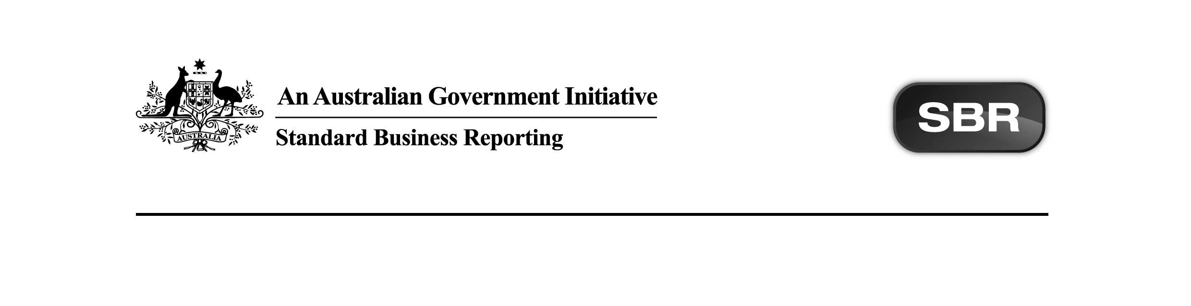
Standard Business Reporting
Australian Taxation Office

ATO NITR 2017 Business Implementation Guides Package v1.0 Contents

Date: 06th July 2017

This document and its attachments are Unclassified | For further information or questions, contact the SBR Service Desk at SBRServiceDesk@sbr.gov.au or call 1300 488 231. International callers may use +61-2-6216 5577

VERSION CONTROL

Version | Release date | Description of changes
1.0 | 22/06/2017 | Updated :  - ATO FITR.0005 2017 Business Implementation Guide.docx  Non-functional -  - Document name changed from ‘ATO FITER.0001 2017 Business Implementation Guide 1.0’ to ‘ATO FITER.0001 2017 Business Implementation Guide’ to conform to document naming standards.  - ATO FTER.0001 2011 Business Implementation Guide.docx  Non-functional:  - Document name changed from ‘ATO FTER.0001 2016 Business Implementation Guide’ to ‘ATO FTER.0001 2011 Business Implementation Guide’ to reflect the actual collaboration year.  - 2.1 Where SBR fits into FTER Lodgment Obligations  Figure 1: SBR interactions and Family trust election process  - Termination points deleted.  - 2.2 Parent Forms  - Collaboration for Trust updated to reflect 2017 service registry entries.  - ATO IEE.0002 2011 Business Implementation Guide.docx  Non-functional -  - 2.1 Where SBR fits into IEE Lodgment Obligations  Figure 1: SBR interactions and Interposed entity election  process  - Termination points deleted.  - 2.2 Parent Forms  - Collaborations updated to reflect 2017 service registry entries.  New :  - ATO CTR.0008 2017 Business Implementation Guide.docx  - ATO PTR.0006 2017 Business Implementation Guide.docx  - ATO SMSFAR.0007 2017 Business Implementation Guide.docx  - ATO TRT.0006 2017 Business Implementation Guide.docx  - ATO TRTAMI.0001 2017 Business Implementation Guide.docx  Present :  - ATO CHTWTHHLD.0001 2014 Business Implementation Guide.docx  - ATO CGNFT.0001 2014 Business Implementation Guide.docx  Pending :  Not applicable.  Removed:  Not applicable.

Previous version history can be found at Appendix A of this document.
Copyright
© Commonwealth of Australia 2017 (see exceptions below).
This work is copyright. Use of this Information and Material is subject to the terms and conditions in the "SBR Disclaimer and Conditions of Use" which is available at http://www.sbr.gov.au. You must ensure that you comply with those terms and conditions. In particular, those terms and conditions include disclaimers and limitations on the liability of the Commonwealth and an indemnity from you to the Commonwealth and its personnel, the SBR Agencies and their personnel.
You must include this copyright notice in all copies of this Information and Material which you create. If you modify, adapt or prepare derivative works of the Information and Material, the notice must still be included but you must add your own copyright statement to your modification, adaptation or derivative work which makes clear the nature of your modification, adaptation or derivative work and you must include an acknowledgement that the adaptation, modification or derivative work is based on Commonwealth or SBR Agency owned Information and Material. Copyright in SBR Agency specific aspects of the SBR Reporting Taxonomy is owned by the relevant SBR Agency.

Table of contents
1 Introduction 5
1.1 Document purpose 5
1.2 Audience 5
1.3 Purpose of this package 5
2 Package contents 6
Appendix A – Prior Version History 8

Introduction

Document purpose
The purpose of this package content note (PCN) is to advise software developers of the package contents and any changes that occur.

Audience
The audience for this Package Content note is software developers who have or are interested in developing Non-individual Income Tax Returns (NITR) 2017 services on either the SBR Core Services or SBR ebMS3 platforms.

Purpose of this package
The purpose of this package is to streamline the way artefacts are presented to software developers.

This package contains Business Implementation Guides for NITR 2017.

Package contents
The table below outlines the package contents.

Name | Document Date | Document Status | Version | Comments | Package Status
ATO CHTWTHHLD.0001 2014 Business Implementation Guide.docx | 06.08.2015 | Final | 1.0 | No change fron prior publication. | Present
ATO CGNFT.0001 2014 Business Implementation Guide.docx | 25.02.2016 | Final | 1.1 | No change fron prior publication. | Present
ATO CTR.0008 2017 Business Implementation Guide.docx | 06.07.2017 | Final | 1.0 |  | New
ATO FITR.0005 2017 Business Implementation Guide.docx | 06.07.2017 | Final | 1.1 | Non-functional -  Document name changed from ‘ATO FITER.0001 2017 Business Implementation Guide 1.0’ to ‘ATO FITER.0001 2017 Business Implementation Guide’ to conform to document naming standards. | Updated
ATO FTER.0001 2011 Business Implementation Guide.docx | 06.07.2017 | Final | 1.1 | Non-functional -  Document name changed from ‘ATO FTER.0001 2016 Business Implementation Guide’ to ‘ATO FTER.0001 2011 Business Implementation Guide’ to reflect the actual collaboration year.  2.1 Where SBR fits into FTER Lodgment Obligations Figure 1: SBR interactions and Family trust election process - Termination points deleted.  2.2 Parent Forms - collaboration for Trust updated to reflect 2017 service registry entries. | Updated
ATO IEE.0001 2011 Business Implementation Guide.docx | 06.07.2017 | Final | 1.1 | Non-functional -  2.1 Where SBR fits into IEE Lodgment Obligations Figure 1: SBR interactions and Interposed entity election process - termination points deleted.  2.2 Parent Forms - collaborations updated to reflect 2017 service registry entries. | Updated
ATO PTR.0006 2017 Business Implementation Guide.docx | 06.07.2017 | Final | 1.0 |  | New
ATO SMSFAR.0007 2017 Business Implementation Guide.docx | 06.07.2017 | Final | 1.0 |  | New
ATO TRT.0006 2017 Business Implementation Guide.docx | 06.07.2017 | Final | 1.0 |  | New
ATO TRTAMI.0001 2017 Business Implementation Guide.docx | 06.07.2017 | Final | 1.0 |  | New

Total artefacts in this Package: | 10
Present artefacts | 2
New artefacts | 5
Updated artefacts | 3
Pending artefacts | 0
Removed artefacts | 0

Appendix A – Prior Version History

Version | Release date | Description of changes
1.0 | 22.06.2017 | First release as a package.

