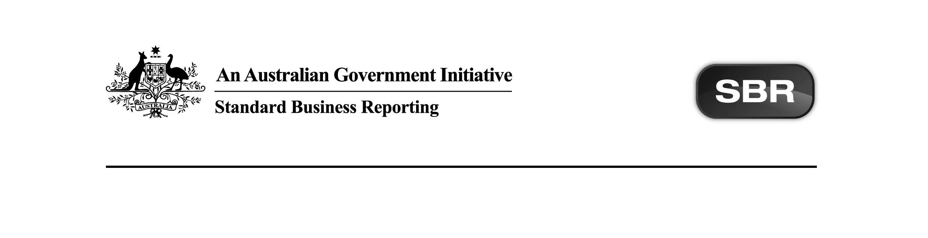
Standard Business Reporting
Australian Taxation Office

TPAR.0001 2013 Package v1.0 Contents

Date: 05 February 2015

This document and its attachments are Unclassified | For further information or questions, contact the SBR Service Desk at SBRServiceDesk@sbr.gov.au or call 1300 488 231. International callers may use +61-2-6216 5577

VERSION CONTROL

Version | Release date | Description of changes
1.0 | 05/02/2015 | Initial release based on previously published artefacts.

ENDORSEMENT
APPROVAL
Chief Solutions Architect
Standard Business Reporting

Grahame Dunnicliff | Project Manager  Strategic Web Services  Australian Taxation Office

Copyright
© Commonwealth of Australia 2015 (see exceptions below).
This work is copyright. Use of this Information and Material is subject to the terms and conditions in the "SBR Disclaimer and Conditions of Use" which is available at http://www.sbr.gov.au. You must ensure that you comply with those terms and conditions. In particular, those terms and conditions include disclaimers and limitations on the liability of the Commonwealth and an indemnity from you to the Commonwealth and its personnel, the SBR Agencies and their personnel.
You must include this copyright notice in all copies of this Information and Material which you create. If you modify, adapt or prepare derivative works of the Information and Material, the notice must still be included but you must add your own copyright statement to your modification, adaptation or derivative work which makes clear the nature of your modification, adaptation or derivative work and you must include an acknowledgement that the adaptation, modification or derivative work is based on Commonwealth or SBR Agency owned Information and Material. Copyright in SBR Agency specific aspects of the SBR Reporting Taxonomy is owned by the relevant SBR Agency.

Table of contents
1 Introduction 5
1.1 Purpose 5
1.2 Audience 5
1.3 Purpose of release 5
1.4 Summary of impacts on software developers 5
1.4.1 In general 5
1.4.2 In detail 5
2 Package contents 6

- Introduction
  - Purpose
The purpose of this document is to advise software developers of the package contents for Standard Business Reporting (SBR) Taxable Payment Annual Report (TPAR) 2013 provided by the Australian Taxation Office (ATO).
  - Audience
The audience for this content note is software developers who have or are interested in developing TPAR.0001 2013 service via the SBR Core Services platform.
  - Purpose of release
The purpose of this release is to streamline the way message artefacts are presented to software developers.

All relevant message artefacts that comprise the TPAR.0001 2013 suite are contained within one zip file.
  - Summary of impacts on software developers
    - In general
Files have been re-named to ensure a consistent naming convention is used, along with file extension from .doc to .docx.

The table in Section 2 Package Contents reflects any new or updated artefacts in the Package Status column.

    - In detail
No functional changes have been made since the previous publication on sbr.gov.au.

- Package contents
The table below outlines the package contents.

Name | Document Date | Document Status | Version | Comments | Package Status
ATO TPAR.0001 2013 Message Implementation Guide.docx | 22.11.2012 | Final | 1.1 | No change. | Final
ATO TPAR.0001 2013 Schematron.zip | 22.11.2012 | Final | 1 | No change. | Final

Total artefacts in the package: 2

